**ASSIGNMENT -2**

**PROBLEM STATEMENT:**

Write a Python program to **store marks scored** in subject **“Fundamental of Data Structure”** by **N students** in the class. **Write functions to compute following:**

a) The **average score** of class.

b) **Highest** score and **lowest** score of class.

c) **Count** of students who were **absent** for the test.

d) **Display** mark with **highest frequency.**

**ANALYSIS OF A PROBLEM STATEMENT:**

**1. Given :**

**Marks** scored in subject “**F**undamental of **D**ata **S**tructure” by **N** Students.

**2. Entity:**

Here in the Problem statement Entity is subject **FDS** and attribute of entity is **Marks**.

**3. Input:**

Here we have to accept subject FDS **marks of N Students** as a input from user.

**4. Data Structure:**

To store/organize the marks in memory we required **LIST** as a data structure.

**5. Output:**

5.1 The average score of class

5.2 Highest Score and Lowest Score of a Class.

5.3 Count of a student who were absent for the Test.

5.4 Display marks with highest frequency.

Source Code:

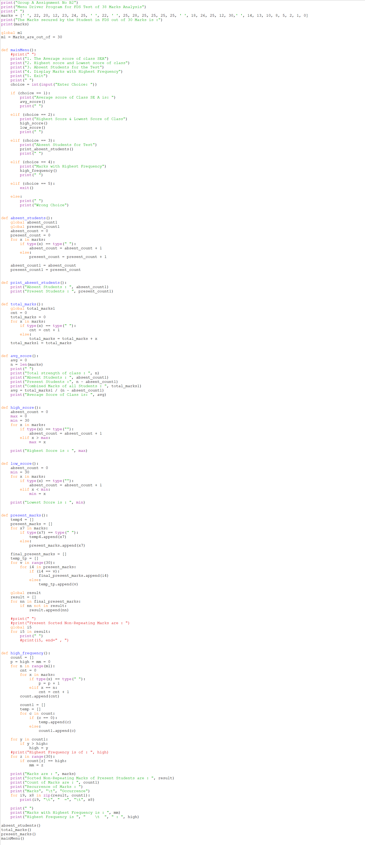

**Output:**

